Supplemental Information
Anti-tumor drug Hinokitiol screening from redox library inhibits the proliferation and cancer stemness of intrahepatic cholangiocarcinoma
Peiying Bai^{1,†}, Chen Ge^{1,†}, Hui Yang^{2,3,†}, Haixu Chen^{4,†}, Lingfei Wan¹, Yuchen Zhang¹, Biao Zhang², Quan Zeng², Zeng Fan², Xuetao Pei^{2,}*, Wen Yue^{2,}*, Xinlong Yan^{1,}*

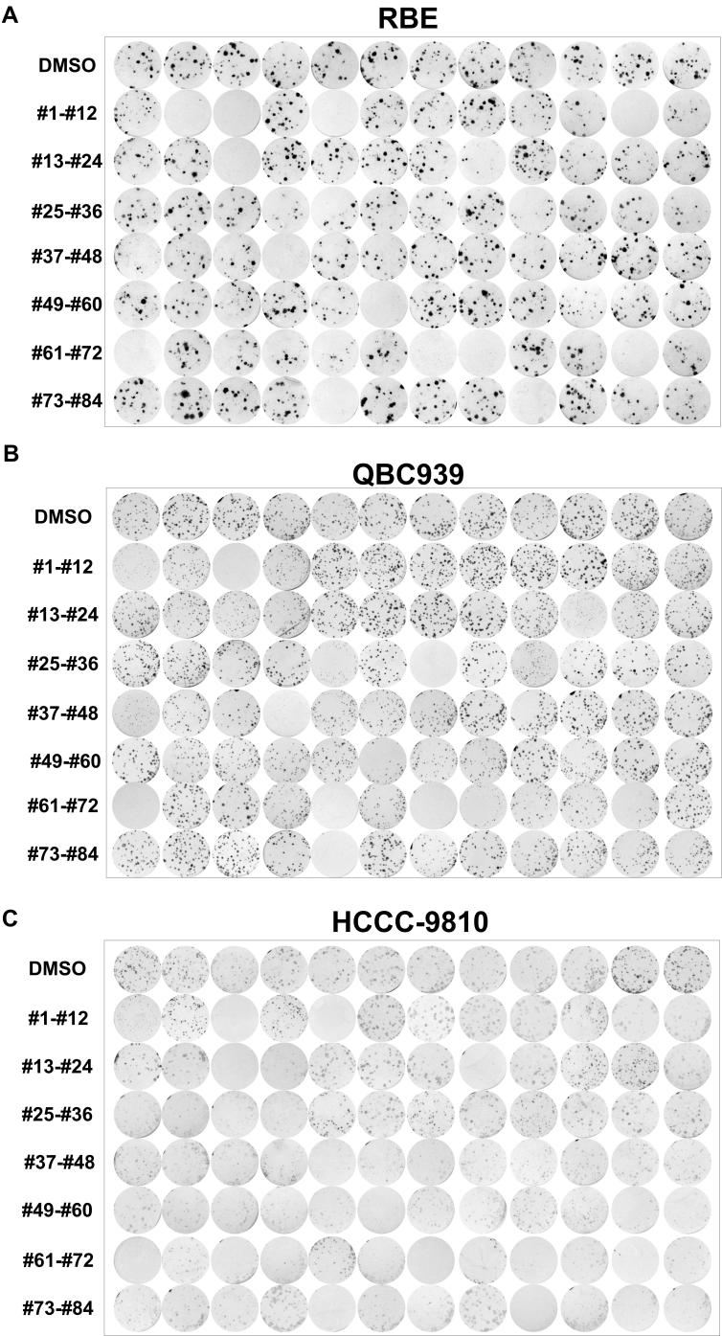
Supplementary Fig. 1. Screening drugs from redox library via clone formation assays. (A) Photos of clone formation in RBE cells treated with small molecules in the redox library. (B) Photos of clone formation in QBC939 cells treated with small molecules in the redox library. (C) Photos of tumor clone formation in HCCC-9810 cells treated with small molecules in the redox library.

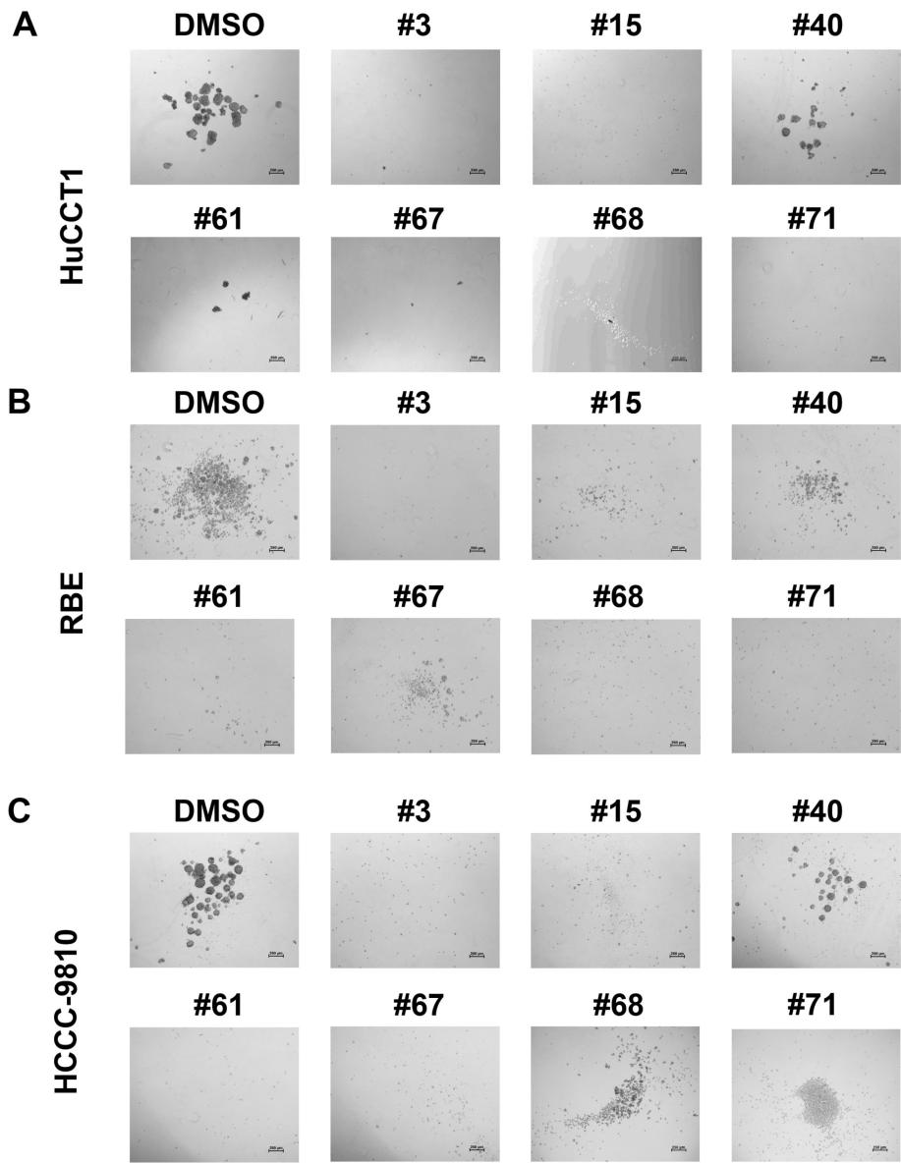
Supplementary Fig. 2. Screening drugs from redox library via tumor sphere formation assays. (A) Photos of tumor sphere formation in RBE cells treated with small molecules in the redox library; Scale bar = 250 μm. (B) Photos of tumor sphere formation in QBC939 cells treated with small molecules in the redox library; Scale bar = 250 μm. (C) Photos of tumor sphere formation in HCCC-9810 cells treated with small molecules in the redox library; Scale bar = 250 μm.
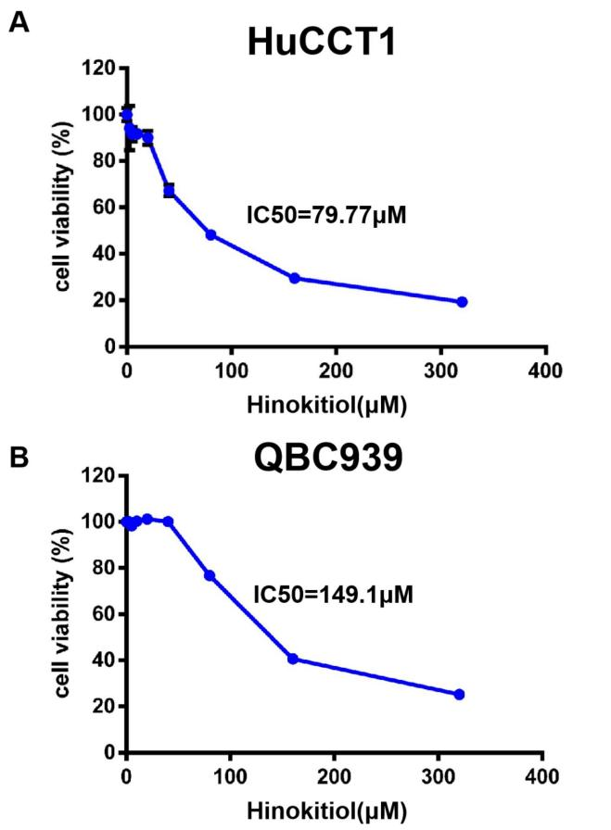
Supplemental Fig. 3. Half maximal inhibitory concentration (IC50) of Hinokitiol on ICC cells. (A) Cell viability of HuCCT1 cell line treated by different concentration of Hinokitiol. (B) Cell viability of QBC939 cell line treated by different concentration of Hinokitiol.

Supplementary Table 1. List of redox library.
NO. | Compound | NO. | Compound
1 | Promethazine·HCl | 43 | BHT
2 | Cumene hydroperoxide | 44 | BHA
3 | β-Lapachone | 45 | Bakuchiol
4 | Resveratrol | 46 | DL-α-Lipoic acid
5 | Hydroquinone | 47 | Eugenol
6 | TEMPOL | 48 | Melatonin
7 | Ferulic acid ethylester | 49 | N-Acetyl-Cysteine
8 | D-α- Tocopherylquinone | 50 | D-γ-Tocopherol
9 | Seratrodast | 51 | Tocopherol succinate
10 | Idebenone | 52 | Ascorbic acid
11 | tert-Butylhydroquinone | 53 | Ascorbyl palmitate
12 | HBED·HCl·H₂O | 54 | n-Octyl caffeate
13 | Ambroxol | 55 | Paeonol
14 | L-Ergothioneine | 56 | Protocatechuic acid
15 | Hinokitiol | 57 | Glutathione
16 | Epigallocatechin gallate | 58 | Carvedilol
17 | Procysteine | 59 | Diludin
18 | Trolox | 60 | Carnosic acid
19 | MCI-186 | 61 | Tanshinone IIA
20 | U83836E·2HCl | 62 | Probucol
21 | U74389G maleate | 63 | EPA
22 | GERI-BP002A | 64 | DCHA
23 | Apigenin | 65 | bis-demethoxycurcumin
24 | Terbinafine·HCl | 66 | Ibuproxam
25 | Rosmarinic acid | 67 | Ciclopirox ethanolamine
26 | Piceatannol | 68 | Thymoquinone
27 | AA-861 | 69 | Thiourea
28 | CDC | 70 | DTT
29 | Ebselen | 71 | N-Ethylmaleimide
30 | Genistein | 72 | Buthionine sulfoximine
31 | Curcumin | 73 | Anethole trithione
32 | Phenidone | 74 | TEMPO
33 | Gossypol | 75 | D609
34 | Gentisic acid | 76 | Captopril
35 | Caffeic acid | 77 | Disulfiram
36 | Baicalein | 78 | 1,2-Dithiole-3-thione
37 | Esculetin | 79 | Selenomethionine
38 | N-Propyl gallate | 80 | Tetramethylpyrazine
39 | ETYA | 81 | Ethoxyquin
40 | CAPE | 82 | Canthaxanthin
41 | NDGA | 83 | β-carotene
42 | Capsaicin | 84 | Retinyl palmitate

Supplementary Table 2. Antibodies in this study.
Antibody | Concentration | Cat. #
GADPH | 1:1000 | Cell Signaling Technology 8884S
SOX2 | 1:1000 | Abcam ab97959
NANOG | 1:1000 | Cell Signaling Technology 3580S
EPCAM | 1:1000 | Abcam ab7504
C-MYC | 1:1000 | Cell Signaling Technology 9402S
ERK | 1:1000 | Cell Signaling Technology 9102S
P38 | 1:1000 | Cell Signaling Technology 9212S
P-ERK | 1:2000 | Cell Signaling Technology 4370S
P-P38 | 1:1000 | Cell Signaling Technology 4511S
CK19 | 1:500 | Abcam ab52625

Supplementary Table 3. The sequences of primers .
Gene | Primer
18s | Forward : AACCCGTTGAACCCCATT  Reverse : CCATCCAATCGGTAGTAGCG
SOX2 | Forward : GCCGAGTGGAAACTTTTGTCG  Reverse : GGCAGCGTGTACTTATCCTTCT
OCT4 | Forward : CTGGGTTGATCCTCGGACCT  Reverse : CCATCGGAGTTGCTCTCCA
EpCAM | Forward : TGATCCTGACTGCGATGAGAG  Reverse : CTTGTCTGTTCTTCTGACCCC
NANOG | Forward : TTTGTGGGCCTGAAGAAAACT  Reverse : AGGGCTGTCCTGAATAAGCAG
MYC | Forward : GGCTCCTGGCAAAAGGTCA  Reverse : CTGCGTAGTTGTGCTGATGT
CD133 | Forward : AGTCGGAAACTGGCAGATAGC  Reverse : GGTAGTGTTGTACTGGGCCAAT
CD24 | Forward : CTCCTACCCACGCAGATTTATTC  Reverse : AGAGTGAGACCACGAAGAGAC
KLF4 | Forward : CCCACATGAAGCGACTTCCC  Reverse : CAGGTCCAGGAGATCGTTGAA
MAPK1 | Forward : TACACCAACCTCTCGTACATCG  Reverse : CATGTCTGAAGCGCAGTAAGATT
MAPK3 | Forward : CTACACGCAGTTGCAGTACAT  Reverse : CAGCAGGATCTGGATCTCCC
MAPK14 | Forward : CCCGAGCGTTACCAGAACC  Reverse : CTACACGCAGTTGCAGTACAT

